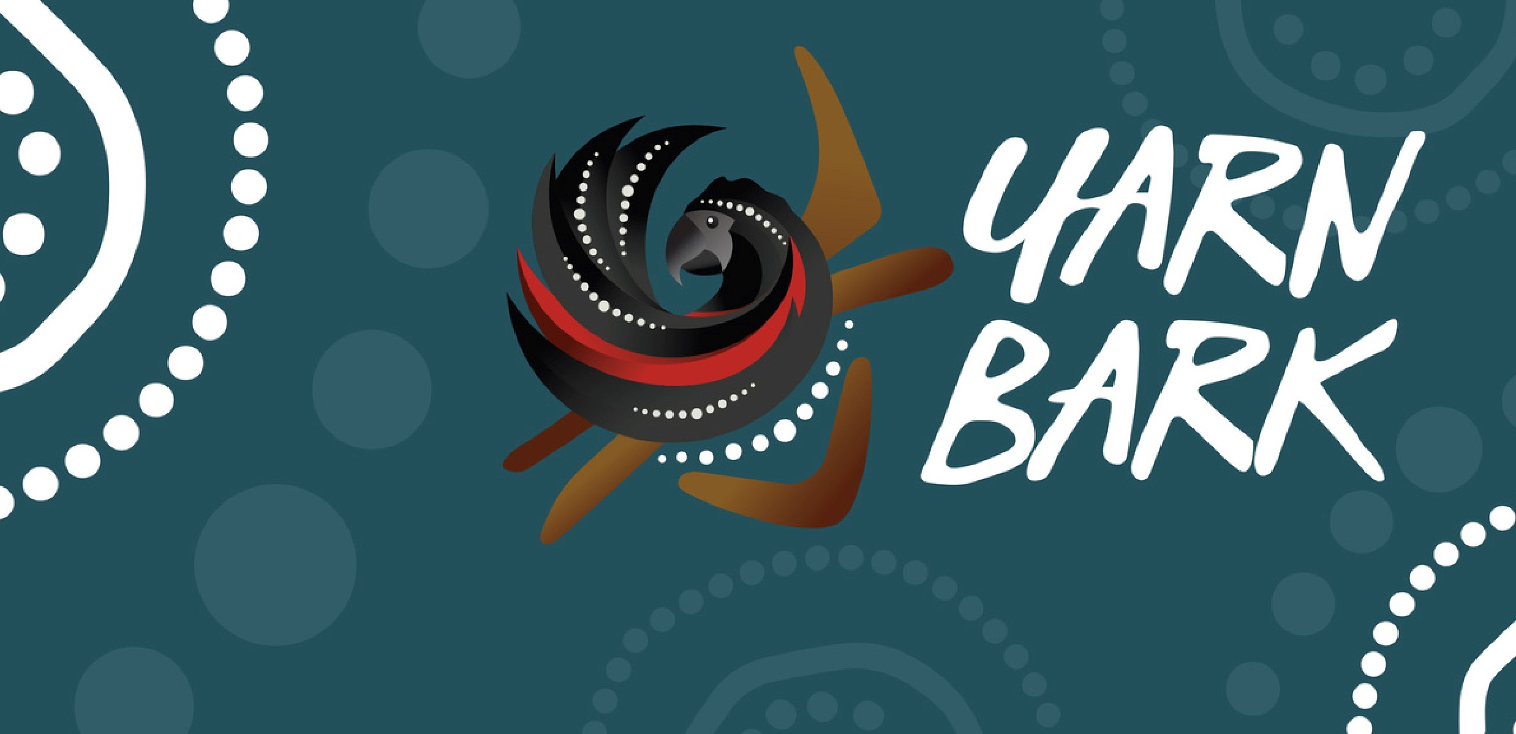

WORKSHOP EXPERIENCE FOR CARERS

June 3 / 10am - 2pm

June 10 / 10am - 2pm

June 24 / 10am - 2pm

Yarn Bark and VACCA are working together to

run Healing our Healers workshops for all carers.

These culturally grounded sessions offer

carers a chance to slow down, reflect, and

connect with themselves and others while

exploring cultural strength, self-care, and

well-being.

CATERING PROVIDED

ALL CARERS WELCOME

ACTIVITES FOR KIDS WHO ATTEND

Ceres Community Centre,

Brunswick

Wunggurtrwil Dhurrung Centre,

Wyndham Vale

Cranbourne Botanical Gardens,

Cranbourne

Please register here:

[Carer Kafe Events Page](https://carerkafe.org.au/learning-and-development/)

